**W5-S2** PRACTICE

*FORMS & INPUTS*

## *What are the objectives for this session?*

* Learn and use various **HTML form input types**
  + *text, checkbox, radio, dropdown, text area, range, color, selector etc.*
* Apply basic CSS styles to enhance the appearance of form inputs
  + *borders, colors, padding, margins etc.*
* Use:  **:focus :hover** : **checked :checked :indeterminate** CSS pseudo-classes

## *How to start?*

* Download **the start code** from the LMS
* Open the folder in VS Code

## *How to submit your work?*

* **Push** your final codeon **your GitHub repository**
* Then **attach the GitHub path** to the MS Team assignment and **turn it in**

## *Are you lost?*

*You can read the following documentation to be ready for this practice:*

* [Guide - WC3 School](https://www.w3schools.com/html/html_forms.asp)
* [The Form element](https://developer.mozilla.org/en-US/docs/Web/HTML/Element/form)
* [HTML Forms](https://www.geeksforgeeks.org/html-forms/)

# **PART 1:** LEARN – 45 MIN

* **Read or watch** resources on internet to learn about **HTML Inputs**:

[Guide - WC3 School](https://www.w3schools.com/html/html_forms.asp)

[The Form element](https://developer.mozilla.org/en-US/docs/Web/HTML/Element/form)

[HTML Forms](https://www.geeksforgeeks.org/html-forms/)

* **Complete** the bellow table.

|  |  |  |
| --- | --- | --- |
| **INPUT TYPE** | **USAGE** | **EXAMPLE** |
| Text | defines a one-line input field for text input | <input type="text"> |
| radio | Radio buttons let a user select ONLY ONE of a limited number of choices | <input **type**="radio"> |
| checkbox | Checkboxes let a user select ZERO or MORE options of a limited number of choices. | <input type="checkbox"> |
| range | The range input type in HTML creates a slider that allows users to select a value from a specified range. It’s a great way to provide an intuitive interface for selecting numeric values, like volume levels or brightness settings. | <input type="range"> |
| submit | defines a button for **submitting** form data to a **form-handler**. | <input type="submit"> |
| textarea | tag defines a multi-line text input control. | <textarea> |
| select | The form attribute specifies the form the drop-down list belongs to. | <select> |
| color | is used for input fields that should contain a color. | <input type="color"> |
| file | defines a file-select field and a "Browse" button for file uploads. | <input type="file"> |

* **Read or watch** resources on internet to learn about  **Inputs styling**:

<https://www.w3schools.com/css/css_form.asp>

* Complete those **mini-challenges** by writing your code on bellow table:

|  |  |
| --- | --- |
| **MINI CHALLENGES** | **YOUR CODE (HTML + CSS)** |
| Highlight the input field when it is focused | <!DOCTYPE *html*>  <html *lang*="en">  <head>  <meta *charset*="UTF-8">  <meta *name*="viewport" *content*="width=device-width, initial-scale=1.0">  <title>Document</title>  <style>  input:focus{  background:cyan;  }  </style>  </head>  <body>  <label *for*="name">Name:</label>  <input *type*="text">  </body>  </html> |
| Change the button background color on hover | <!DOCTYPE *html*>  <html *lang*="en">  <head>  <meta *charset*="UTF-8">  <meta *name*="viewport" *content*="width=device-width, initial-scale=1.0">  <title>Document</title>  <style>  button{  color:black;  background: red;  width:*100px*;  height:*50px*;  border-radius: *10px*;  }  button:hover{  opacity: *0.5*;  }  </style>  </head>  <body>  <button>login</button>  </body>  </html> |
| Create a search bar with rounded corners and a shadow effect | <!DOCTYPE *html*>  <html *lang*="en">  <head>  <meta *charset*="UTF-8">  <meta *name*="viewport" *content*="width=device-width, initial-scale=1.0">  <title>Document</title>  <style>  input{  border-radius: *5px*;  box-shadow: *1px* *1px* *1px* red;  }  </style>  </head>  <body>  <label *for*="search">search: </label>  <input *type*="search" *placeholder*="search here">  </body>  </html> |
| Display a different style when the checkbox is checked |  |
| **HARD!**  Style a checkbox to have three states: unchecked, checked, and indeterminate.  TIP  Use CSS pseudo-classes  (:checked and :indeterminate)  for styling. |  |

* Some **groups will be selected to present** and **explain** their work to the whole class

# **PART 2:** PRACTICE – 45 MIN

You need to reproduce – *as close as possible* - the bellow table.

Before coding, identify the following point:

* **Elements**: What are the different inputs you will need?
* **Layout**: what kind of CSS layout do you need? Why?
* **Input styling**: What are the styles you need to apply on your inputs?

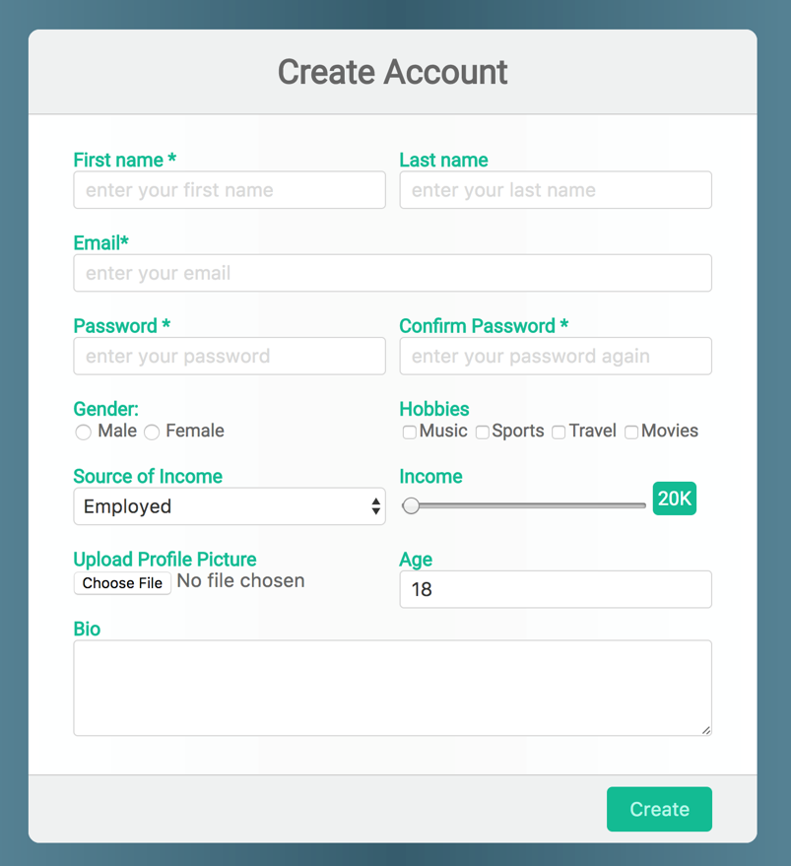

*Be as close as possible from this mock up*

# **PART 3:** THINK + PAIR + SHARE – 90 MIN

***STEP 1: INDIVIDUAL WORK*** *– 15 MIN*

1. Brainstorm a **form idea** based on a *scenario*

*e.g., contact form, login form, survey form, registration form…*

1. List the **elements** you think the form should include

*e.g.: text area, password, color selector, radio button, list…*

1. List any **specific CSS styles** the form should have

*e.g., hover effects, focus styles, alignment, layout, columns, rows…*

***STEP 2: COLLABORATIVE WORK*** *– 45 MIN*

1. Decide on a **single form idea** to develop.
2. **Sketch the form structure** and styling on paper
3. Start implementing the **HTML** structure and **CSS** styles collaboratively.

***STEP 3: SHARE*** *– 30 MIN*

* Pair with another team and demonstrates your project, explaining:
  + The **form’s purpose** and use case
  + How you structured the **HTML**
  + The **CSS** techniques used for styling
  + The **challenges you have faced** and how you resolved them
* Some **groups will be selected to present** their work to the whole class